**Picture Round.**



Figure 1 Figure 2 (nickname is good as well)



Figure 3 Figure 4

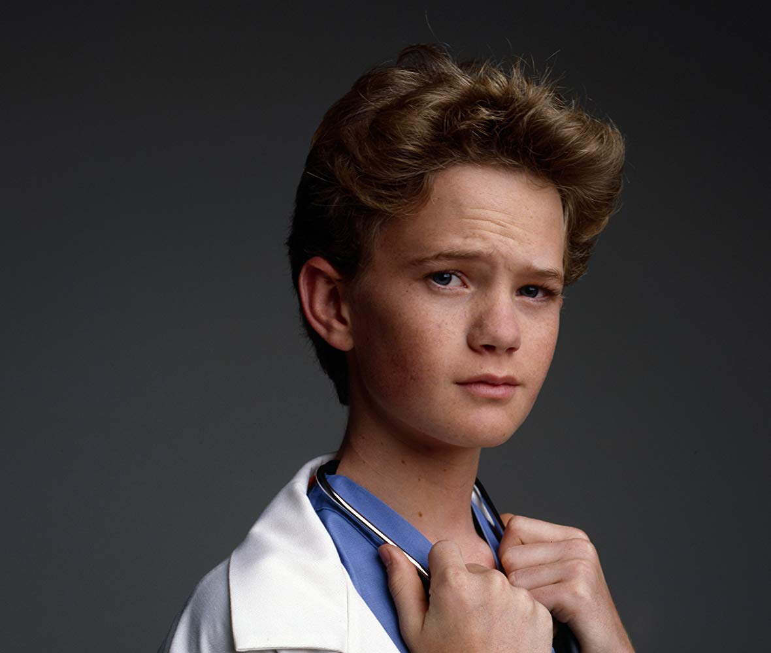

Figure 5 (full name of actor) Figure 6 (full name!)

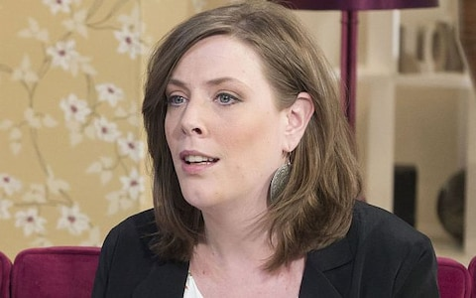

Figure 7 Figure 8 (last name is sufficient)

 

Figure 9 Figure 10

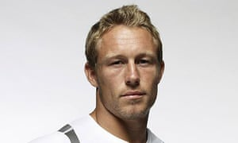

*Figure 11 Figure 12 (name of band)*